# Problem Statement:

This problem statement was taken from the book of Hadi Sadat of chapter 12, example 12.4.

The example depicts a two-area power system connected by a tie line having the following parameters on a 1000 MVA common Base.

|  |  |  |
| --- | --- | --- |
| Parameters | Area 1 | Area 2 |
| Speed Regulation | $R_{1}$ = 0.05 | $R_{1}$ = 0.0625 |
| Frequency sensitive load coefficient | $D_{1}$ = 0.6 | $D_{1}$ = 0.9 |
| Inertia Constant | $H_{1}$ = 5 | $H_{1}$ = 4 |
| Base Power | 1000 MVA | 1000 MVA |
| Governor Time Constant | $T_{g1}$ = 0.2 sec | $T_{g1}$ = 0.3 sec |
| Turbine Time Constant | $T_{t1}$ = 0.5 sec | $T_{t1}$ = 0.6 sec |
| Synchronizing Power coefficients | 2.0 | |

The both power plants are operating in parallel at the nominal frequency of 60 Hz. All of sudden a load change of 187.5 MW occurs in Area 1. Due to this, system frequency will vary as well as power plant have to enhance their generation in order to meet the increased load demand. In this situation, we have to determine the new steady state frequency and the change in the tie line flow.

# Initial approach to design the two-area system using MATLAB Simulink:

The model consists of transfer functions of governor, turbine, generator named as rotating mass and load. In the feedback, speed regulation is placed. It means that to model, the power plant, we need transfer function block, gain block, sum block and input signal block.

If single area power plant is successfully modeled in MATLAB/Simulink software, then two area power system can be easily modelled just by repeating the same procedure of single area power system with only addition of tie line power flow known as Delta p12.

# **Transfer Functions**

$$Governer\left(Area 1\right)=\frac{1}{t_{g1}s+1}=\frac{1}{0.2s+1}$$

$$Turbine\left(Area 1\right)=\frac{1}{t_{t1}s+1}=\frac{1}{0.5s+1}$$

$$Inertia and load\left(Area 1\right)=\frac{1}{2H_{1}s+D_{1}}=\frac{1}{10s + 0.6}$$

$$Speed Regulation\left(Area 1\right)=\frac{1}{R_{1}}=20$$

$$Governer\left(Area 2\right)=\frac{1}{t_{g2}s+1}=\frac{1}{0.3s+1}$$

$$Turbine\left(Area 2\right)=\frac{1}{t_{t2}s+1}=\frac{1}{0.6s+1}$$

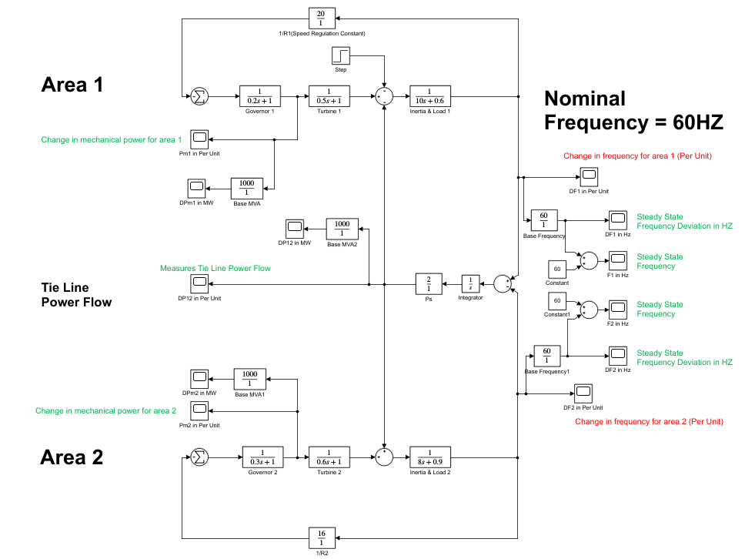 $Inertia and load\left(Area 2\right)=\frac{1}{2H_{2}s+D_{2}}=\frac{1}{\begin{aligned}8s+0.9 \\ \end{aligned}}$

$$Speed Regulation\left(Area 2\right)=\frac{1}{R_{2}}=16$$

Fig: Drawn and simulated in MATLAB Simulink.

Using the transfer functions the block diagram has been drawn and there is a tie line between two area for ensuring power flow. The tie line power basically represents the change in angle of generator 1 and 2.

This change in angle occur due to change in frequency.

# **Input Signal:**

Now we need the input signal which consist of change in load demand. For this purpose, we need step input signal.

Per unit load change in area 1, $∆P_{L1}=\frac{187.5}{1000}=0.1875 p.u$

0.1875 p.u this is what is our step input value.

# **Different Measurements after load change:**

|  |  |
| --- | --- |
|  | Frequency Deviation in Area 1 $DF_{1}= - 0.3 Hz$ |
|  | Final Frequency of Area 1 $$F_{1}=59.7 Hz$$ |
|  | Frequency Deviation in Area 2 $$DF_{2}= - 0.3 Hz$$ |
|  | Final Frequency of Area 2, $$F_{2}=59.7 Hz$$ |
|  | Change in mechanical power in area 1, $Dpm_{1}=100 MW$ |
|  | Change in mechanical power in area 2, $Dpm_{2}=80 MW$ |

Thus, Area 1 increases the generation by 100 MW and Area 2 by 80 MW at the new operating frequency of 59.7 Hz.

The total load change in generation is 180 MW, which is 7.5 MW less than the 187.5 MW load change because of the change in the area loads due to frequency drop.

|  |  |
| --- | --- |
|  | Tie line power flow, $$∆P_{12} = -84.5 MW$$ |

That is 84.5 MW flows from Area 2 to Area 1. 80 MW comes from the increased generation in Area 2, and 4.5 MW comes from the reduction in area 2 load due to frequency drop.

# **Design Flaws and Critical Points to be noted:**

1. It may be noted that load of 187.5 MW is changed in Area 1 power system. However, from the results, it has been observed that both generators have enhanced their generation to meet the increased load demand. Practically this is not true. In the real practice, if sudden load is changed in any area, then each area has to absorb its own changes or in other words, it has to be supplied by the generator of that area only.
2. It means that for a load change of 187.5 MW, the change in mechanical power of area 1 should be increased to 187.5 MW only. Whereas, the change in mechanical power of area 2 must remain zero. Furthermore, change in tie line power should also remain zero. To do this, **some modifications are needed** in the model in such a way that change of load in any area may cause the change of generation in that area only.
3. Furthermore, it may be noted that frequency of the system has reached up to 59.7 Hz. It has not recovered to 60 Hz. Due to which despite of 187.5 MW change in load, only 180 MW of load has been supplied by both generators. It still lacks 7.5 MW. When frequency will recover to 60 Hz, both generators will be able to supply the whole 187.5 MW. It means that we some controlling techniques need to be implemented in order to bring the frequency to its nominal value of 60 Hz.
4. Moreover, it may be noted that change in mechanical power of generator 2 is 80 MW. It means that 80 MW of power is supplied from area 2 to area 1 through tie line. However, the simulation results have shown that the tie line power flow is 84. 5 MW. Now, question may arise that how it is possible? The answer to this question is that 80 MW is supplied from Area 2, whereas 4.5MW of power is reduced in area 2 due to frequency drop. It is because frequency stays at 59.7Hz.
5. This reduction in frequency causes the reduction in load, due to which this additional power of 4.5 MW also flows towards Area 1. Therefore, overall, 84.5 MW of power flows from tie line.

**Controlling techniques needed:**

* Conventional LFC is based upon tie line bias control, where each area tends to reduce the area control error (ACE) to zero. The control error for each area is given as below.
$$ACE_{i }= \sum_{j=1}^{n}{∆P_{ij }}+ K_{i} ×∆ω$$

* The area bias $K_{i}$ determines the amount of interaction during a disturbance in the neighboring areas.
* An overall satisfactory performance is achieved when speed regulation constant is selected equal to the frequency bias factor of that area given by:
$$B_{i}= \frac{1}{R_{i}}+ D_{i}$$

* The value of $B_{1}$ and $B_{2}$ as calculated from the example data is as below:
$$B_{1}= \frac{1}{R_{1}}+ D_{1 }= \frac{1}{0.05}+0.6=20.6$$

$$B_{2}= \frac{1}{R_{2}}+ D_{2 }= \frac{1}{0.0625}+0.9=16.9$$

* Thus, the ACE for a two area system are-
$$ACE_{1 }= ∆P_{12 }+ B_{1} ×{∆ω}_{1}$$

$$ACE_{1 }=0+ B_{1} ×0=0$$

$$ACE_{2 }= ∆P_{21 }+ B_{2} ×{∆ω}_{2}$$

$$ACE_{2 }=0+ B_{2} ×0=0$$

* Area bias factor K1 = K2 = 0.3

# Final and corrected design of the two-area system using MATLAB Simulink:

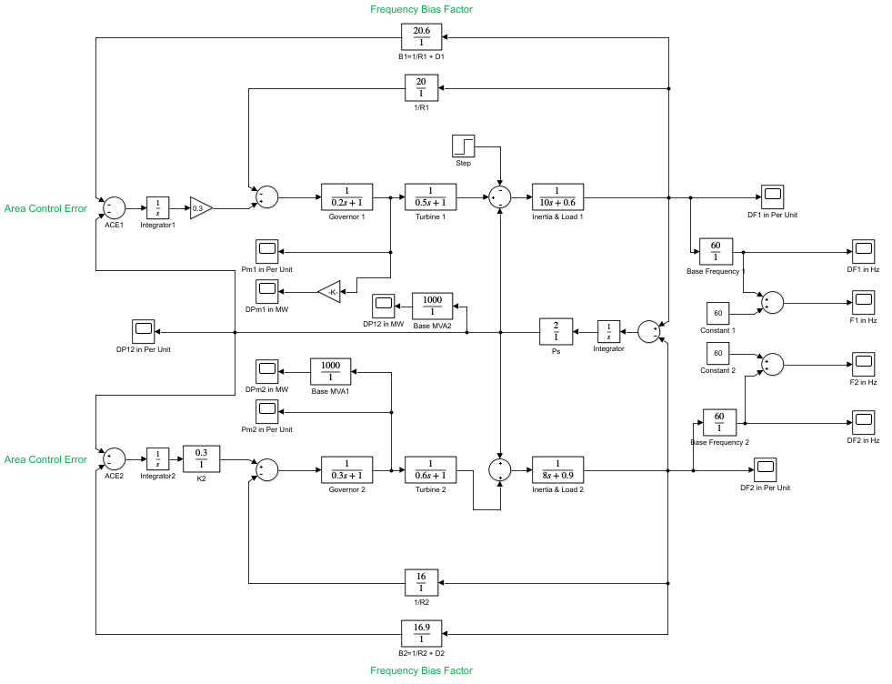

|  |  |
| --- | --- |
|  | Frequency Deviation in Area 1 $DF_{1}= 0 Hz$ |
|  | Final Frequency of Area 1 $$F_{1}=60 Hz$$ |
|  | Frequency Deviation in Area 2 $$DF_{2}= 0 Hz$$ |
|  | Final Frequency of Area 2, $$F_{2}=60 Hz$$ |
|  | Change in mechanical power in area 1, $Dpm_{1}=187.6 MW$ |
|  | Change in mechanical power in area 2, $Dpm_{2}=0 MW$ |

Thus, Area 1 increases the generation by 187.5 MW and Area 2 by 0 MW and the frequency is 60 Hz.

There is no frequency drop and that’s why there is no loss and the whole 187.5 MW is generated by Area 1 only.

So, 0 MW flows from Area 2 to Area 1. There is no generation in Area 2.